Ideation Phase

Define the Problem Statements

Date | 31 January 2026
Team ID | LTVIP2026TMIDS34329
Project Name | Toycraft tales: tableau's vision into toy manufacturer data
Maximum Marks | 2 Marks

Customer Problem Statement Template:
Create a problem statement to understand your customer's point of view. The Customer Problem Statement template helps you focus on what matters to create experiences people will love.
A well-articulated customer problem statement allows you and your team to find the ideal solution for the challenges your customers face. Throughout the process, you’ll also be able to empathize with your customers, which helps you better understand how they perceive your product or service.
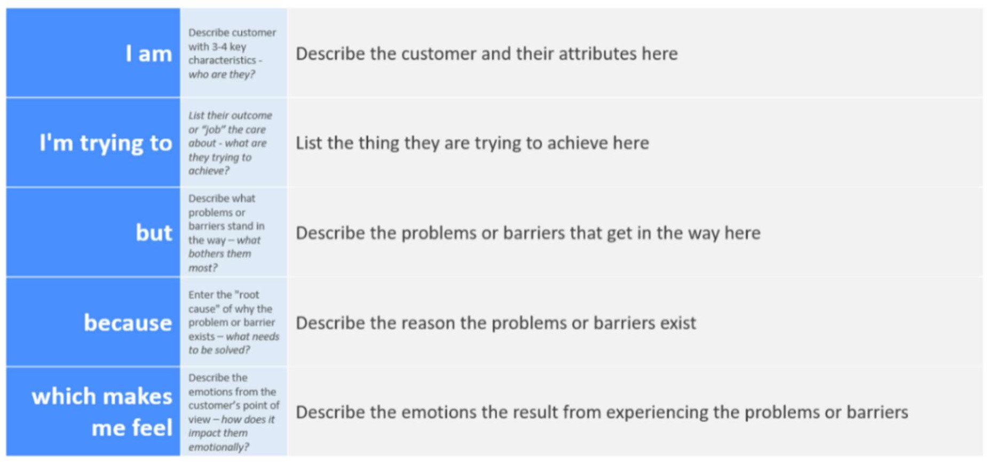

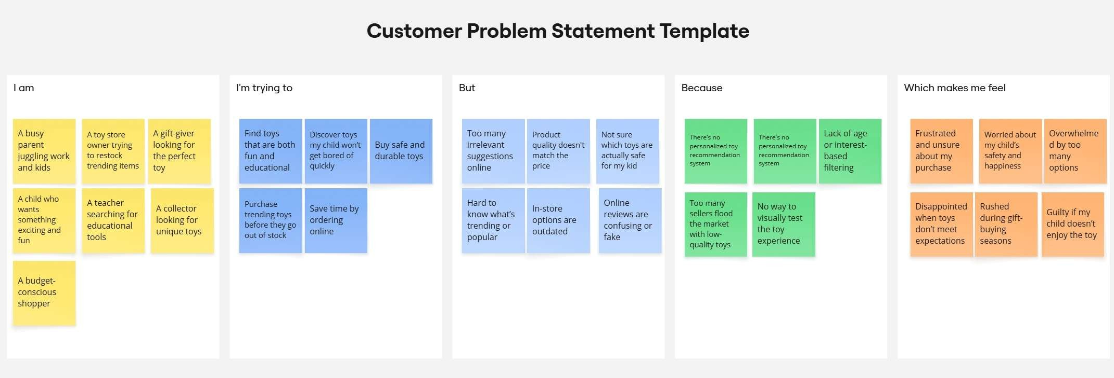

Problem Statement (PS) | I am (Customer) | I’m trying to | But | Because | Which makes me feel
PS-1 | A busy parent juggling work and kids | Find toys that are both fun and educational | Too many irrelevant suggestions online | Platforms focus on sales, not child engagement | Worried about my child’s safety and happiness
PS-2 | A toy store owner trying to restock trending items | Purchase trending toys before they go out of stock | In-store options are outdated | Too many sellers flood the market with low- quality toy | Disappointed when toys don’t meet expectations

EMPATHY PHASE MAP
